**DATA ANALYTICS ASSIGNMENT 2**

R.SRIVANI

4th B.Tech (CSE)

VNITSW

20NN1A05A1

**DONUT CHART**

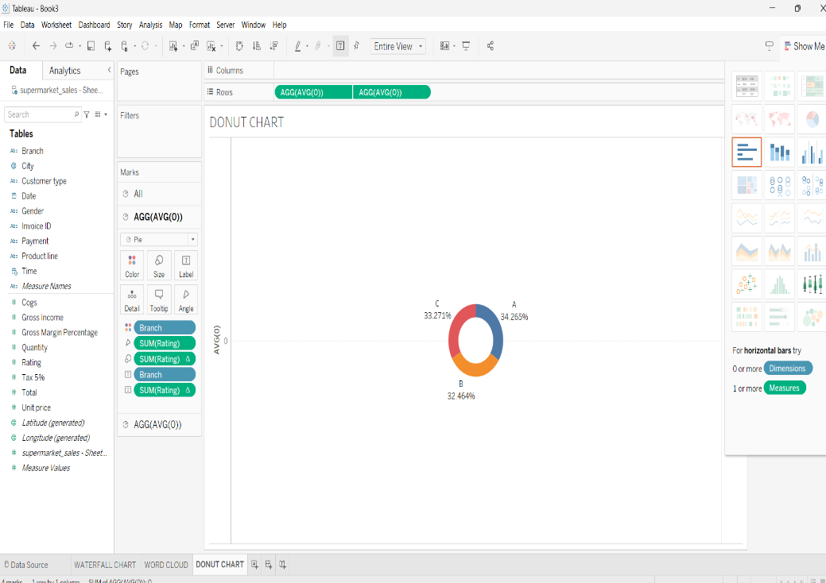

**AREA CHART**

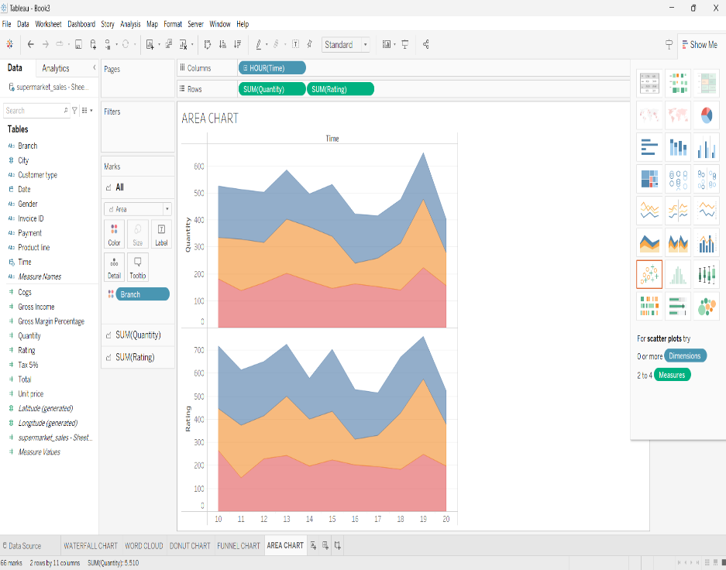

**TEXT TABLE  
 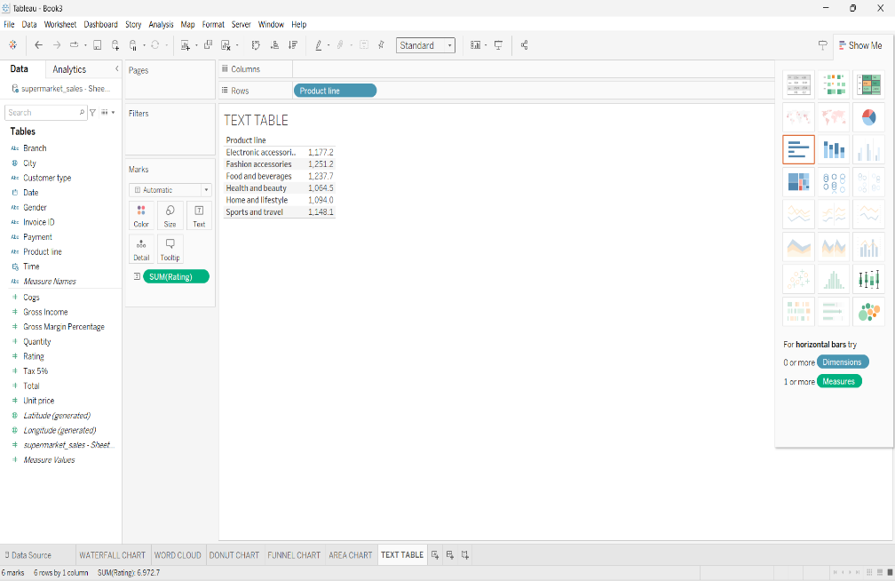**

**HIGHLIGHTED TABLE**

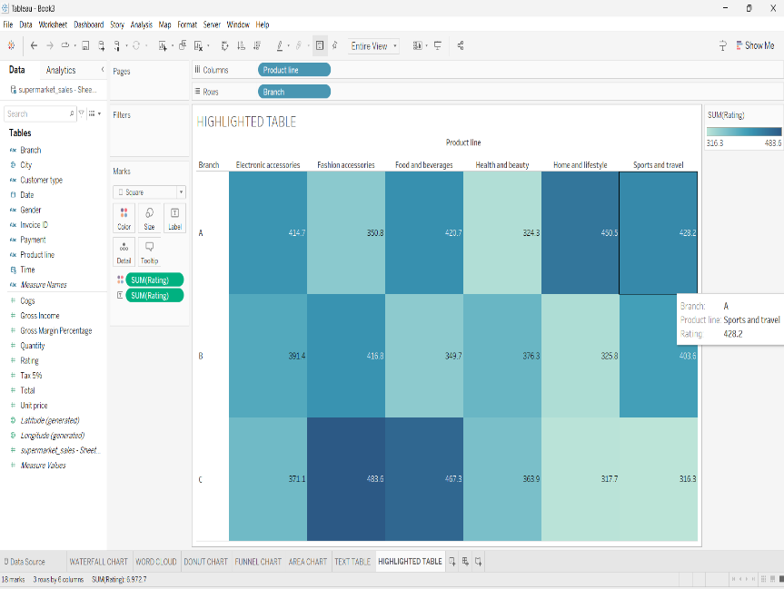

**WORD CLOUD**

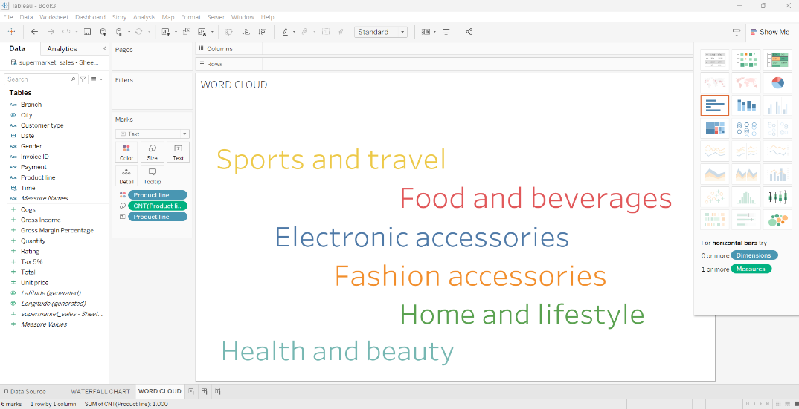

**FUNNEL CHART**

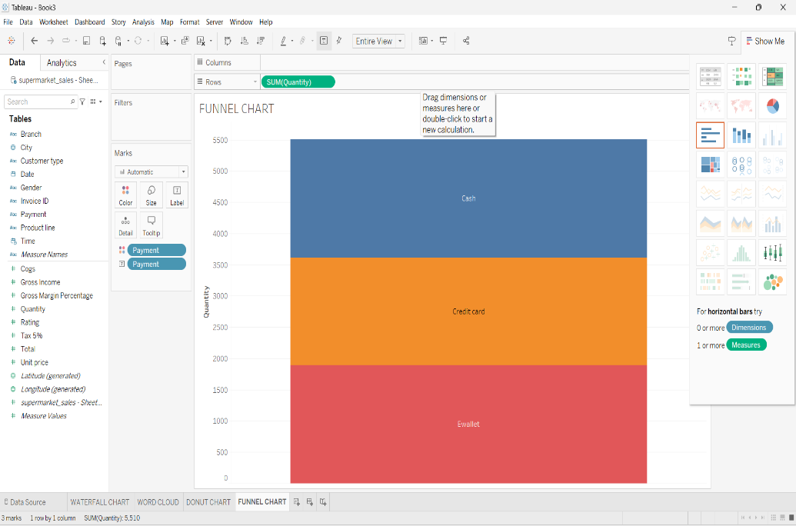

**WATERFALL CHART**

